National Housing and Homelessness Agreement

Indicator (i) - Supplementary technical document

This document is designed to assist in the understanding of the calculation of Indicator (i) – An increase in the proportion of people who were at risk that receive assistance to avoid homelessness.

- METeOR specifications
- Logic diagrams
- State/territory counting rules for the client-level

METeOR specifications
National Performance Indicators for the National Housing and Homelessness Agreement – The proportion of people who are at risk of homelessness that receive assistance to avoid homelessness, (Client level), 2021

Identifying and definitional attributes
Metadata item type: | Indicator
Indicator type: | Indicator
Short name: | NPI NHHA: At risk people that receive assistance to avoid homelessness (Client level).
METEOR identifier: | 750317
Registration status: | - No registration status
Description: | The proportion of clients who are at risk of homelessness that receive assistance to avoid homelessness.
Rationale: | The National Housing and Homelessness Agreement (NHHA), which commenced in 2018, funds homelessness services with the objective of improving access to affordable, safe and sustainable housing across the housing spectrum from crisis housing to home ownership, including to prevent and address homelessness, and to support social and economic participation. The NHHA specifies the National Performance Indicators that assess and monitor the efficacy of homelessness services. There is a range of homelessness services across Australia; however, this indicator specification measures only those services delivered by SHS.  The Indicator is calculated annually for each financial year.  This indicator measures performance from the perspective of a client, by examining outcomes for clients at risk of homelessness who avoided homelessness after receiving Specialist Homelessness Services (SHS).
Indicator set: | National Performance Indicators for the National Housing and Homelessness Agreement (2021)
Quality statement: | Specialist Homelessness Services Collection, 2019–20; Quality Statement AIHW Data Quality Statements, Superseded 23/11/2021

Collection and usage attributes
Computation description: | Coverage/Scope  The indicator is derived from support periods; the period of time during which a client is receiving SHS support. Within each support period, agencies collect client information that allows for the derivation of homeless status at numerous points in time:  - A week before the client presents to the agency  - At the time of presentation  - At the last service provision date of each month during support  - At the end of the support period  Only points 2 and 4 are included in this indicator.  A client may have support periods from a single agency or multiple agencies. All support periods for a client are given consideration in the derivation of the indicator.  A client is in-scope for this indicator if, at any time during the first six months of a reporting period—hereafter the in-scope period—they commenced a support period ‘at risk’ of homelessness (that is, homeless status was derived as at risk at time point 2 above.  The derivation for the homeless status of a client or a support period is described in Glossary item SHS Homeless status.  Methodology:  Homeless status for in-scope clients is examined for 6 months—hereafter follow-up period—from the start of their first recorded in-scope at-risk support period. The follow-up period is derived by incrementing the start date by 6 months. For example, for the in-scope period from 1 July 2020 to 31 December 2020, if a client’s first at-risk support period commenced on 20 August 2020 then the follow-up period would commence on 20 August 2020and end on 20 February 2021.  Example nomenclature for date/s  Date/s Nomenclature  1 Jul 2020 to 31 Dec 2020 In-scope period  20 Aug 2020 Example, First recorded in-scope ‘At risk’ support period  20 Aug 2020 to 20 Feb 2021 Follow up period  Any client that is recorded as not homeless (at time points 2 or 4) for all support periods throughout the follow up period is considered to have avoided homelessness.
Computation: | (Numerator ÷ Denominator) x 100
Numerator: | Number of at-risk clients without recorded homelessness in the 6-month follow up period.
Numerator data elements: | Data Element / Data Set  Data Element  Homeless status at the end of support (derived)—not homeless  Data Source  Specialist Homelessness Services Data Collection  NMDS / DSS  Specialist Homelessness Services NMDS 2019-
Denominator: | Number of clients with at least one support period with an at risk homeless status in the in-scope period.
Denominator data elements: | Data Element / Data Set  Data Element  Homeless status at presentation (derived)—at risk  Data Source  Specialist Homelessness Services Data Collection  NMDS / DSS  Specialist Homelessness Services NMDS 2019-
Disaggregation: | 2020–21 — Nationally, by:  - Sex and Age group.  2020–21 — State and territory by:  - Sex and Age group.
Disaggregation data elements: | Data Element / Data Set  Data Element  NHHA priority homelessness cohorts - people exiting institutions and care into homelessness  Disaggregation  2020–21 — Nationally, by:  - Sex.  2020–21 — State and territory by:  - Sex.  Data Element / Data Set  Data Element  NHHA priority homelessness cohorts - older people  Disaggregation  2020–21 — Nationally, by:  - Sex.  2020–21 — State and territory by:  - Sex.  Data Element / Data Set  Data Element  NHHA priority homelessness cohorts - women and children affected by family and domestic violence  Disaggregation  2020–21 — Nationally, by:  - Sex.  2020–21 — State and territory by:  - Sex.  Data Element / Data Set  Data Element  NHHA priority homelessness cohorts - Indigenous Australians  Disaggregation  2020–21 — Nationally, by:  - Sex.  2020–21 — State and territory by:  - Sex.  Data Element / Data Set  Data Element  NHHA priority homelessness cohorts - children and young people  Disaggregation  2020–21 — Nationally, by:  - Sex.  2020–21 — State and territory by:  - Sex.
Comments: | A client may have support periods from a single agency or multiple agencies. All support periods for a client are given consideration in the derivation of the indicator.  Exclusions  Clients excluded  The following clients that commenced a support period at risk within the scope period are excluded from this indicator:  - A client with only one support period (that brings them in scope) and that support period ends after the 6-month follow up period. These clients are excluded as there is limited information to ascertain if the clients were assisted to avoid homelessness.  - A client whose homeless status during the 6-month follow up period is always Not stated. These clients are excluded as there is limited information to ascertain if the services provided to the clients assisted them in avoiding homelessness.  - A client with two or more support periods commencing on the same day; one of which is the at risk support period that brings the client into scope and the other homeless. These clients are excluded as their homeless status is ambiguous at time point 2, unless they have a subsequent at risk support period that subsequently brings them into scope.  Support periods excluded for in-scope clients  There are certain support periods for in-scope clients that are excluded from the indicator calculations. These are:  - Support periods provided by central intake services where those services do not provide direct services to clients.  - A support period that was ongoing at the time point that the client became in-scope. This support period is excluded as it does not reflect whether the services provided to the client during the 6-month follow up period after an at-risk assessment assisted in them avoiding homelessness.  Homelessness assessment points excluded for in-scope clients  Some support period time points (2 or 4) are not considered when calculating the numerator for an in-scope client. These are:  - The time point 2 for At risk support period(s) that commence on the same day as the in-scope At risk support period.  Data collection  Data are collected monthly from agencies participating in the collection. All agencies that receive funding under the NHHA (previously the NAHA or the NPAH) to provide specialist homelessness services are in scope for the SHSC, although some agencies are exempted from supplying data. Agencies submit data on the periods of support provided to clients.

Representational attributes
Representation class: | Percentage
Data type: | Real
Unit of measure: | Person
Format: | N[NN].N

Data source attributes
Data sources: | Data Source  Specialist Homelessness Services Data Collection  Frequency  Specialist Homelessness Services collect data on an ongoing basis and submit the data to the Australian Institute of Health and Welfare on a monthly basis.  Data custodian  Australian Institute of Health and Welfare

Accountability attributes
Reporting requirements: | Agency supplied data.
Organisation responsible for providing data: | Specialist homelessness services agencies.
Accountability: | Australian Institute of Health and Welfare

Source and reference attributes
Submitting organisation: | Australian Institute of Health and Welfare
Reference documents: | CFFR (Council on Federal Financial Relations) 2018. National Housing and Homelessness Agreement 2018. Council on Federal Financial Relations, Canberra. Viewed 15 October 2021,  The National Housing and Homelessness Agreement | Federal Financial Relations

Relational attributes
Related metadata references: | See also  National Performance Indicators for the National Housing and Homelessness Agreement – The proportion of people who are at risk of homelessness that receive assistance to avoid homelessness, (Service level), 2021 No registration status

Registry management attributes
Created by: | Kline Nazareth
Created date/time:
Last updated by: | Kline Nazareth
Last updated date/time:
Workgroup: | AIHW Homelessness Reporting and Data Development workgroup

National Performance Indicators for the National Housing and Homelessness Agreement – The proportion of people who are at risk of homelessness that receive assistance to avoid homelessness, (Service level), 2021

Identifying and definitional attributes
Metadata item type: | Indicator
Indicator type: | Indicator
Short name: | NPI NHHA: At risk people that receive assistance to avoid homelessness (Service level).
METEOR identifier: | 750434
Registration status: | - No registration status
Description: | The proportion of support periods in which people who are at risk of homelessness that receive assistance to avoid homelessness
Rationale: | The National Housing and Homelessness Agreement (NHHA), which commenced in 2018, funds homelessness services with the objective of improving access to affordable, safe and sustainable housing across the housing spectrum from crisis housing to home ownership, including to prevent and address homelessness, and to support social and economic participation. The NHHA specifies the National Performance Indicators that assess and monitor the efficacy of homelessness services. There is a range of homelessness services across Australia; however, this indicator specification measures only those services delivered by SHS.  The Indicator is calculated annually for each financial year.  This indicator measures performance by analysing the extent to which a period of Specialist Homelessness Services (SHS) support successfully prevented homelessness for an at risk client.
Indicator set: | National Performance Indicators for the National Housing and Homelessness Agreement (2021)
Quality statement: | Specialist Homelessness Services Collection, 2019–20; Quality Statement AIHW Data Quality Statements, Superseded 23/11/2021

Collection and usage attributes
Computation description: | Coverage/Scope  The indicator is derived from support periods; the period of time during which a client is receiving SHS support. Within each support period, agencies collect client information that allows for the derivation of homeless status at numerous points in time:  - A week before the client presents to the agency  - At the time of presentation  - At the last service provision date of each month during support  - At the end of the support period  Only points 2 and 4 are included in this indicator.  For a support period to be in scope the homeless status of the client must be known (that is, either at risk or homeless) at both points (2) and (4). If homeless status is unknown at either of the time points the support period is excluded from both the numerator and the denominator.  Only closed support periods are included (those which have points 4 and 2 and derive a positive integer).  Only support periods that start and end in the reporting period are included.  The derivation for the homeless status of a client or a support period is described in Glossary item SHS Homeless status.
Computation: | (Numerator ÷ Denominator) x 100
Numerator: | Number of support periods where the homeless status at presentation was at risk and the homeless status at the end of the support period was not homeless.
Numerator data elements: | Data Element / Data Set  Data Element  Homeless status at the end of support (derived)—not homeless  Data Source  Specialist Homelessness Services Data Collection  NMDS / DSS  Specialist Homelessness Services NMDS 2019-
Denominator: | Number of support periods where the homeless status at presentation was at risk.
Denominator data elements: | Data Element / Data Set  Data Element  Homeless status at presentation (derived)—at risk  Data Source  Specialist Homelessness Services Data Collection  NMDS / DSS  Specialist Homelessness Services NMDS 2019-
Disaggregation: | 2020–21 — Nationally, by:  - Sex and Age group.  2020–21 — State and territory by:  - Sex and Age group.
Disaggregation data elements: | Data Element / Data Set  Data Element  NHHA priority homelessness cohorts - people exiting institutions and care into homelessness  Disaggregation  2020–21 — Nationally, by:  - Sex.  2020–21 — State and territory by:  - Sex.  Data Element / Data Set  Data Element  NHHA priority homelessness cohorts - older people  Disaggregation  2020–21 — Nationally, by:  - Sex.  2020–21 — State and territory by:  - Sex.  Data Element / Data Set  Data Element  NHHA priority homelessness cohorts - women and children affected by family and domestic violence  Disaggregation  2020–21 — Nationally, by:  - Sex.  2020–21 — State and territory by:  - Sex.  Data Element / Data Set  Data Element  NHHA priority homelessness cohorts - Indigenous Australians  Disaggregation  2020–21 — Nationally, by:  - Sex.  2020–21 — State and territory by:  - Sex.  Data Element / Data Set  Data Element  NHHA priority homelessness cohorts - children and young people  Disaggregation  2020–21 — Nationally, by:  - Sex.  2020–21 — State and territory by:  - Sex.
Comments: | Data collection  Data are collected monthly from agencies participating in the collection. All agencies that receive funding under the NHHA (previously the NAHA or the NPAH) to provide specialist homelessness services are in scope for the SHSC, although some agencies are exempted from supplying data. Agencies submit data on the periods of support provided to clients.

Representational attributes
Representation class: | Percentage
Data type: | Real
Unit of measure: | Service event
Format: | N[NN].N

Data source attributes
Data sources: | Data Source  Specialist Homelessness Services Data Collection  Frequency  Specialist Homelessness Services collect data on an ongoing basis and submit the data to the Australian Institute of Health and Welfare on a monthly basis.  Data custodian  Australian Institute of Health and Welfare

Accountability attributes
Reporting requirements: | Agency supplied data.
Organisation responsible for providing data: | Specialist homelessness services agencies.
Accountability: | Australian Institute of Health and Welfare

Source and reference attributes
Submitting organisation: | Australian Institute of Health and Welfare
Reference documents: | CFFR (Council on Federal Financial Relations) 2018. National Housing and Homelessness Agreement 2018. Council on Federal Financial Relations, Canberra. Viewed 15 October 2021,  The National Housing and Homelessness Agreement | Federal Financial Relations

Relational attributes
Related metadata references: | See also  National Performance Indicators for the National Housing and Homelessness Agreement – The proportion of people who are at risk of homelessness that receive assistance to avoid homelessness, (Client level), 2021 No registration status

Registry management attributes
Created by: | Kline Nazareth
Created date/time:
Last updated by: | Kline Nazareth
Last updated date/time:
Workgroup: | AIHW Homelessness Reporting and Data Development workgroup

Logic diagrams

Logic diagrams for the client-level indicator
The logic diagrams with the associated reasoning aid in the understanding of the specifications for the client-level indicator. These step through the possible service profile scenarios visually representing:
- Timing of the in-scope six-month data period, and the full financial year of data (dark black lines)
- Illustrative first support period commencement date (20 Aug 2020) within the in-scope six-month data period and an illustration of the end of the six-month follow up period for that individual client (dark green lines)
- Support period examples (horizontal black lines), illustrating various scenarios including:
  - Clients with a single support period who are in-scope for the indicator denominator
  - Clients with multiple support periods who are in-scope for the indicator denominator
  - Assessment of whether a client is in the numerator
  - Broad overview of the assessment of Not stated housing situation and clients with multiple support periods commencing on the same day.

Denominator assessment – Diagram 1: Illustration of clients with a single support period who are in-scope for the indicator denominator

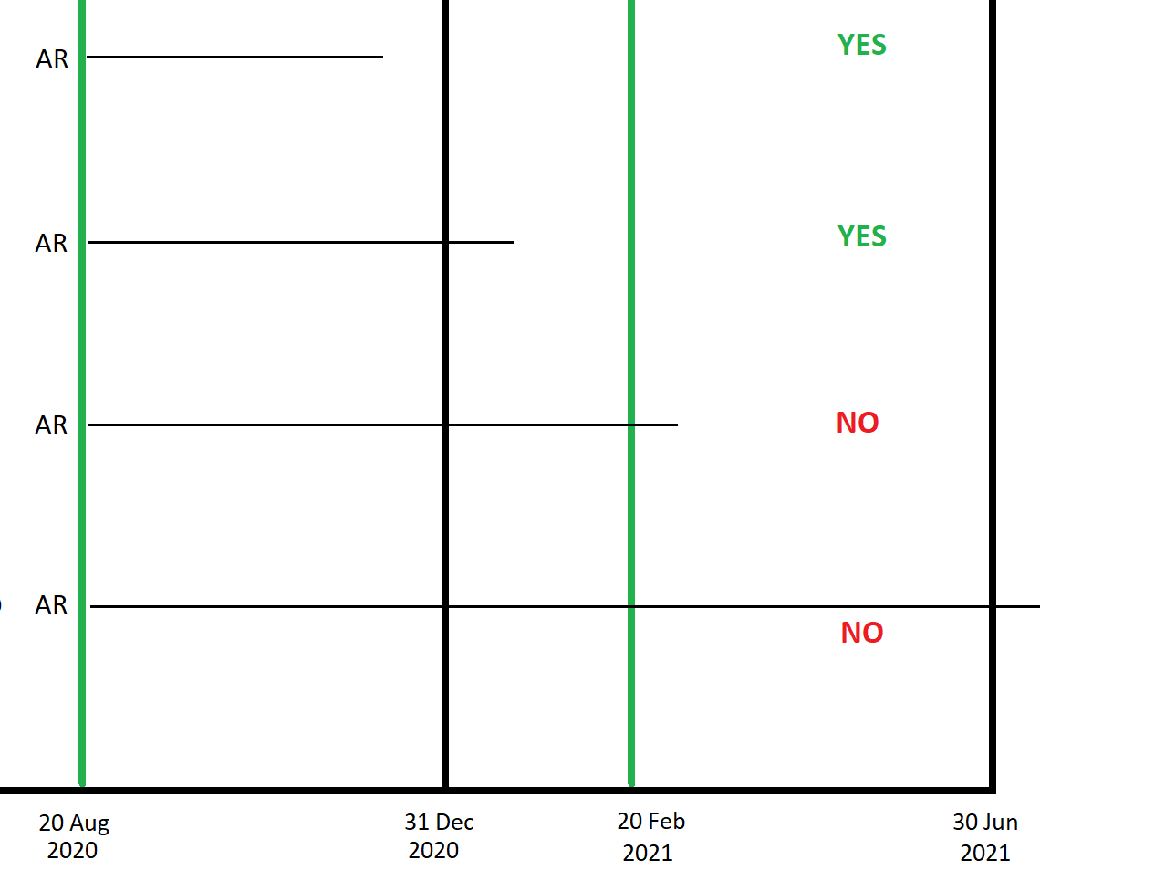
AR = At risk. H = Homeless.
Open ended lines represent any possible housing situation at that specific time point.

The following table relates to Diagram 1 above which is a basic illustration of clients with single support periods. It lists the reason for the inclusion/exclusion of a client from the denominator.
Client # | Inclusion/exclusion and reason
Client A | YES. A support period that commenced At Risk and ended within six month follow up period.
Client B | YES. A support period that commenced At Risk and ended within the six-month follow up period. Client B demonstrates that the support period may end after the end of the in-scope period, as long as it ends within the six-month follow up period.
Client C | NO. The single At Risk support period ends after the six-month follow up period.
Client D | NO. The At Risk support period ends after the six-month follow up period, illustrating a very long support period that extends beyond the financial year.

Denominator assessment – Diagram 2: Illustration of clients with multiple support periods who are in-scope for the indicator denominator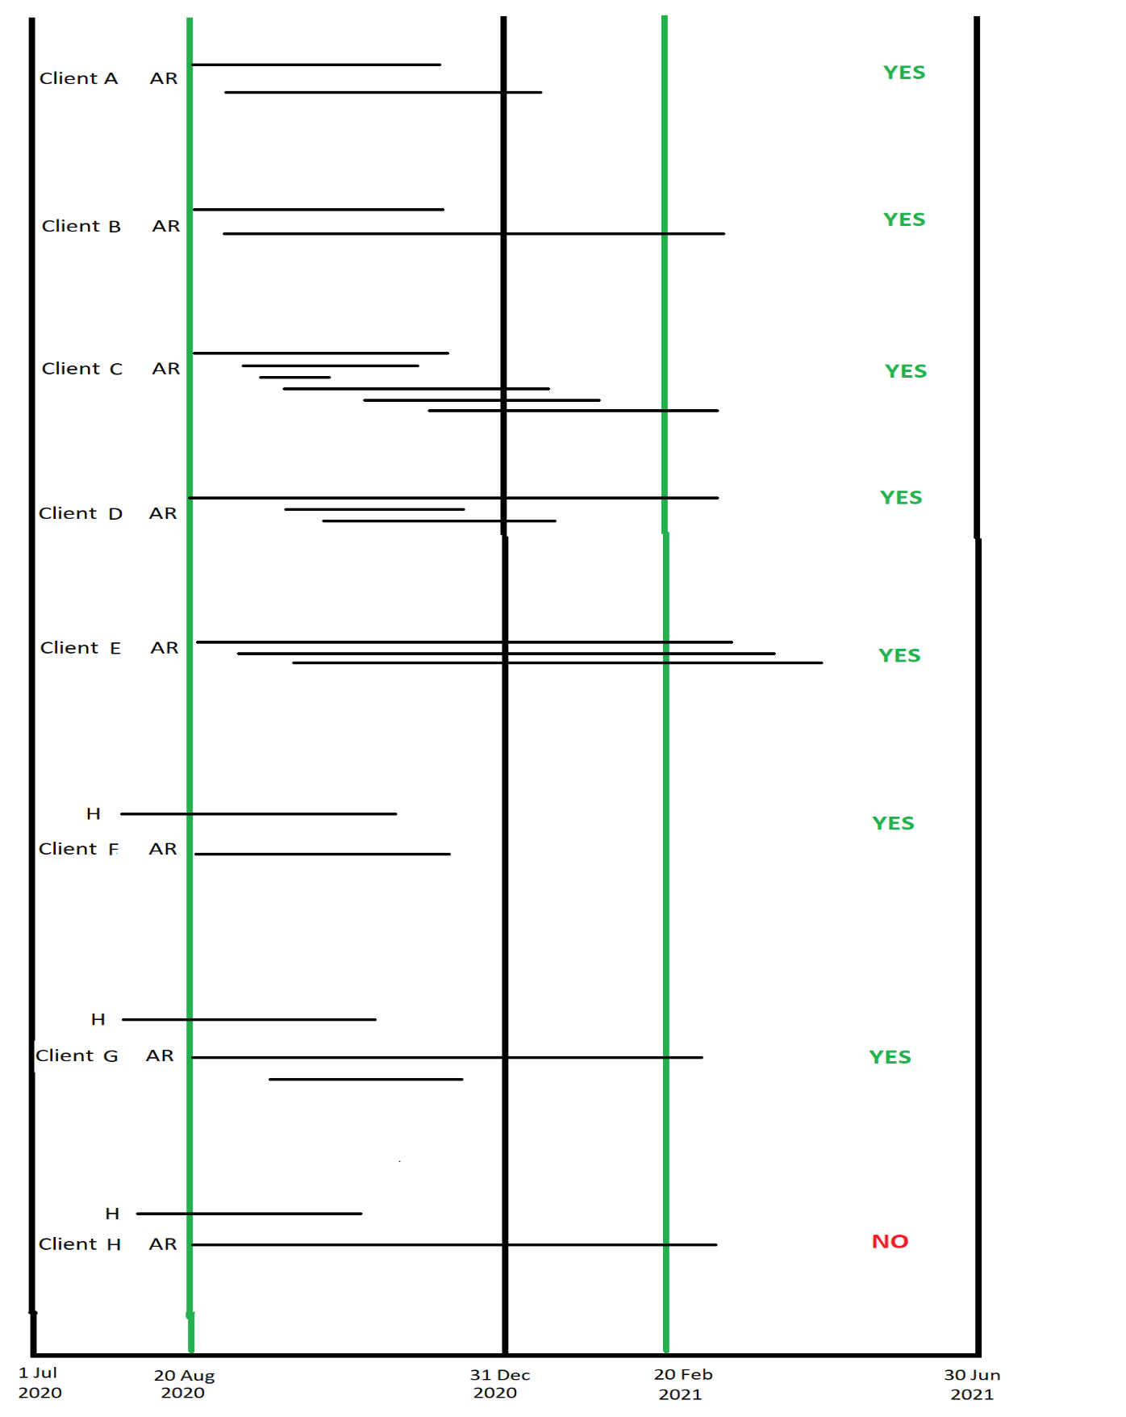
AR = At risk. H = Homeless.
Open ended lines represent any possible housing situation at that specific time point.

The following table relates to Diagram 2 above. It lists the reason for the inclusion/exclusion of a client from the denominator for clients with multiple support periods (black lines). The ‘ends’ of the support periods illustrate the various scenarios that underpin the inclusion/exclusion of the client in the denominator.
Client # | Inclusion/exclusion and reason
Client A | YES. A support period that commenced At Risk and ended within the six-month follow-up period. The other support period does not affect the client’s inclusion/exclusion from the denominator.
Client B | YES. A support period that commenced At Risk and ended within the six-month follow-up period. The second support period does not affect the client’s inclusion/exclusion from the denominator even though the second support period ends after the six-month follow-up period.
Client C | YES. A support period that commenced At Risk and ended within the six-month follow-up period. The various other support periods do not affect the client’s inclusion/exclusion from the denominator.
Client D | YES. An At Risk support period that commenced within the in-scope period, AND they had at least one other support period that commenced within the six-month follow up period, even though the first support period ended after the six-month follow up period. In this example, the client had two other support periods that commenced within the six-month follow up period. This illustration assumes that there is at least one housing situation recorded among the other support periods; else this client would be excluded.
Client E | YES. An At Risk support period that commenced within the in-scope period AND they had at least one other support period that commenced within the six-month follow up period, even though the first support period ended after the six-month follow up period. In this example, the client had two other support periods that commenced within the six-month follow up period. The fact that these two support periods also ended after the six-month follow up period does not have an affect the client’s inclusion/exclusion from the denominator but it does assume that the housing situation was valid in one of the other two support periods, else, this client would be excluded.
Client F | YES. A support period that commenced At Risk and ended within the six-month follow-up period. The other support period that commenced Homeless before the At Risk support period is not considered when assessing the client’s inclusion/exclusion from the denominator.
Client G | YES. This client shares features with Client D and Client F, that is, an At Risk support period that commenced within the in-scope period AND they had at least one other support period that commenced within the six-month follow up period. The other support period that commenced Homeless before the At Risk support period is not considered when assessing the client’s inclusion/exclusion from the denominator.
Client H | NO. The At Risk support period ends after the six-month follow up period. The other support period that commenced Homeless before the At Risk support period is not considered when assessing the client’s inclusion/exclusion from the denominator even though it ended during the in-scope period.

Numerator assessment – Diagram 3: Illustration of the whether a client is included in the numerator
The following shows which time points (2 or 4) for support periods are in-scope for assessment of the numerator. That is, an open line without label indicate that time point is out of scope. The figure does not illustrate any Not stated housing situations – all of these are out of scope for assessment of whether a client is in the numerator. There is an overall assessment (right hand side) whether the client is included or excluded from the numerator.
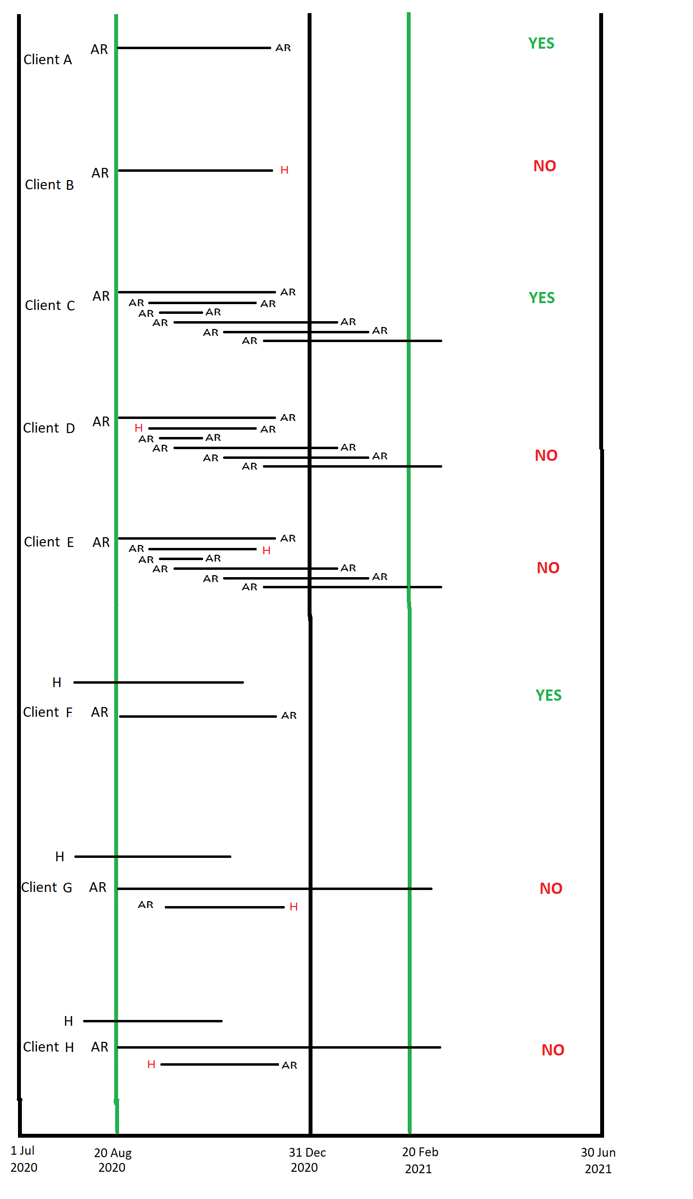
AR = At risk. H = Homeless.
Open ended lines represent any possible housing situation at that specific time point.

The table relates to Diagram 3 above. All the clients are included in the denominator. The table lists the reason for the inclusion/exclusion of a client from the numerator.
Client # | Inclusion/Exclusion and Reason
Client A | YES. The At Risk support period ended At Risk i.e. avoided homelessness.
Client B | NO. The At Risk support period ended Homeless.
Client C | YES. Time points 2 and 4 for all support periods within the six-month follow up period were At Risk. In other words, there was not a single time point (2 or 4) for support periods as Homeless within the six-month follow up period.
Client D | NO. There is a time point 2 as Homeless within the six-month follow up period.
Client E | NO. There is a time point 4 as Homeless within the six-month follow up period.
Client F | YES. The At Risk support period ended At Risk. The other support period that commenced Homeless before the At Risk support period is not considered when assessing the client’s inclusion/exclusion in the numerator.
Client G | NO. There is a time point 4 as Homeless within the six-month follow up period. The other support period that commenced Homeless before the At Risk support period is not considered when assessing the client’s inclusion/exclusion in the numerator.
Client H | NO. There is a time point 2 as Homeless within the six-month follow up period. The other support period that commenced Homeless before the At Risk support period is not considered when assessing the client’s inclusion/exclusion in the numerator.

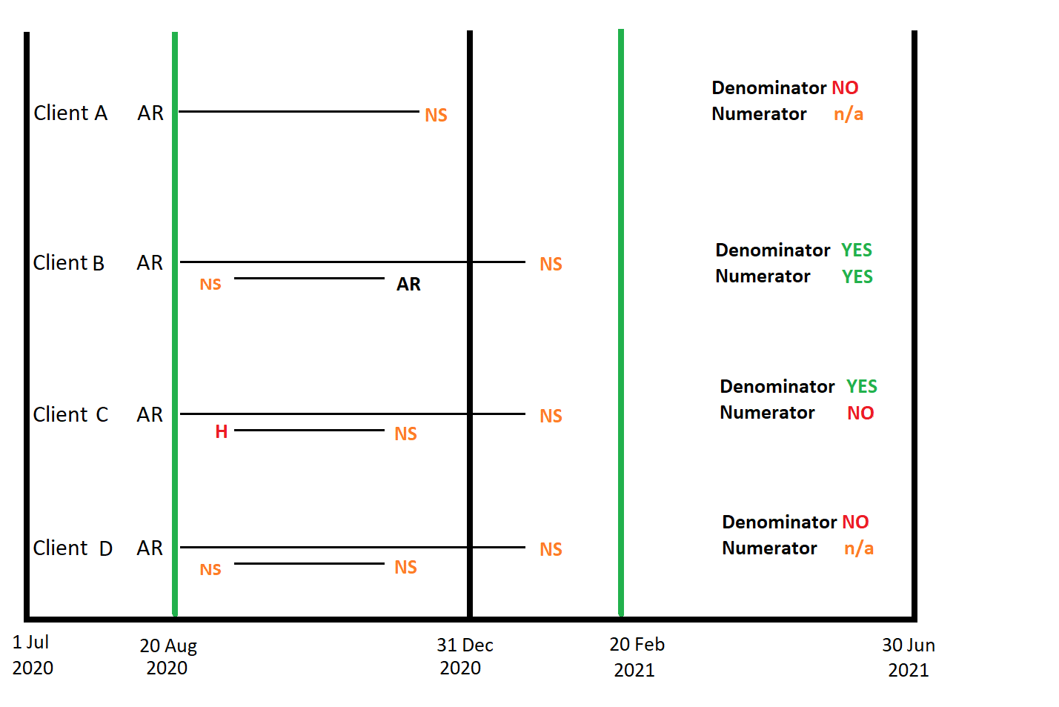
Diagram 4: Inclusion assessment diagram for those with Not stated housing situation: Broad overview of clients with Not stated housing situation support periods either at presentation or at the end of support
AR = At risk. H = Homeless. NS = Not Stated.
Open ended lines represent any possible housing situation at that specific time point.

The table relates to Diagram 4 above. The table lists the reason for the inclusion/exclusion of a client from the denominator and numerator. Please note - Not stated at time points 2 or 4 are excluded from consideration in both the denominator and the numerator.
Client # | Inclusion/exclusion and reason
Client A | Denominator - NO. An At Risk support period that ended in the six-month follow up period as Not Stated. Even though the support period ended within the six-month follow up period, it was neither Homeless nor At Risk therefore the assessment is not valid.  Numerator – n/a.
Client B | Denominator - YES. An At Risk support period AND there was at least one time point (2 or 4) of a support period where homeless status was known, that is either Homeless or At Risk. In this instance, the homeless status at time point 4 of the second support period was known.  Numerator - YES. All valid homeless status time points were At Risk.
Client C | Denominator - YES. An At Risk support period AND there was at least one time point (2 or 4) of a support period where homeless status was known, that is either Homeless or At Risk, within the follow up period. In this instance, the homeless status at time point 2 of the second support period was known.  Numerator - NO. The homeless status at time point 2 of the second support period was Homeless.
Client D | Denominator - NO. Homelessness status at time points (2 or 4) of all support periods within the six-month follow up period was Not Stated.  Numerator – n/a.

Diagram 5: Assessment diagram for clients with multiple support periods that commence on the same day
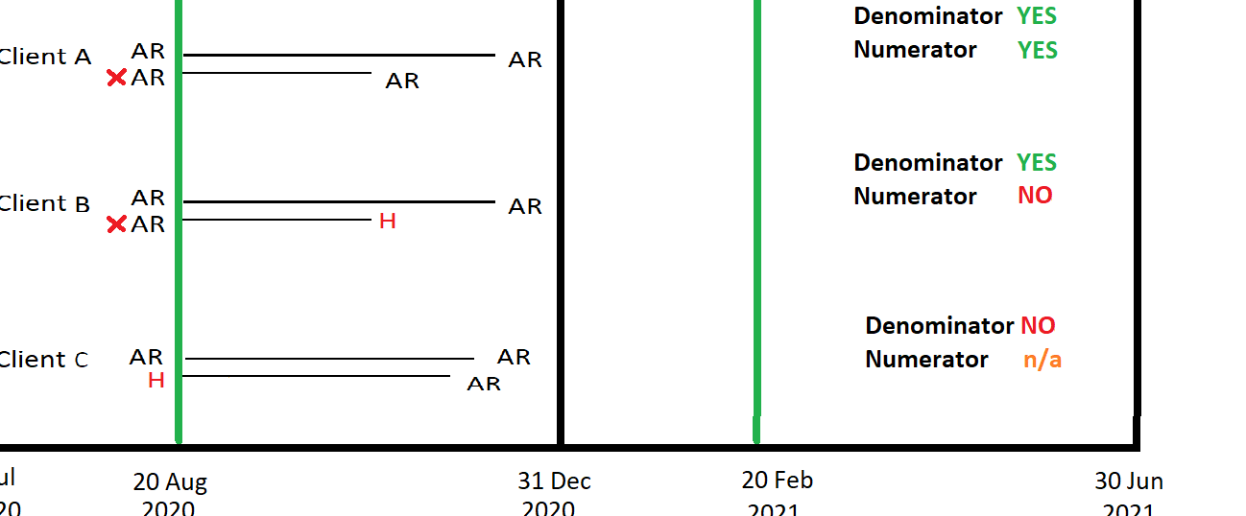
X
Indicates the second (or multiple) support periods commencing on the same day with homeless status at risk are not included in derivation of the numerator.

The table relates to Diagram 5 above. The table lists the reason for the inclusion/exclusion of a client from the denominator and numerator.
Client # | Inclusion/exclusion and reason
Client A | Denominator - YES. The client had an At Risk support period that ended in the six-month follow up period.  Numerator - YES. None of the time points (2 or 4) were Homeless for any support period within the six-month follow up period.  Please note that the At Risk status at time point 2 of the second support period is not included in the derivation of the numerator.
Client B | Denominator - YES. The client had an At Risk support period that ended in the six-month follow up period.  Numerator - NO. The homeless status at time point 4 of the second support period was Homeless.  Please note that the At Risk status at time point 2 of the second support period is not included in the derivation of the numerator.
Client C | Denominator - NO. Although the client had an At Risk support period that ended in the six-month follow up period, they also had another support period commencing on the same day as Homeless. In this instance, the true homeless status at commencement is ambiguous and hence is excluded from the denominator.  Numerator – n/a.

State/territory counting rules for the client-level

The intent of indicator (i) client-level is to measure the performance of each state/territory’s system to assist vulnerable people to avoid homelessness, that is, it assesses the client’s pathway within each state/territory independent of their pathway in another state/territory. There may be a scenario when a client who commences at risk in one state and then moves to another state/states during the six-month follow up period. For clients who move interstate, the assessment of the effectiveness of the system to assist with avoiding homelessness is limited to only those support periods in one jurisdiction. That is, there is potential for a client to be enumerated in two states if they have at least one in-scope at risk support throughout the period in more than one state/territory. However, nationally, the client would only be enumerated once.

